What is CTE:  a degenerative disease of the brain (form of brain damage) that occurs in athletes or others who have experienced repetitive concussions or other trauma to the brain.  How can you get it?  CTE is developed from head injuries over time. It varies depending on the person. The symptoms are very similar to a serious concussion but can not be diagnosed until the athlete is diseased. |  |  | Chronic Traumatic Encephalopathy (CTE)  Issues & Concerns…  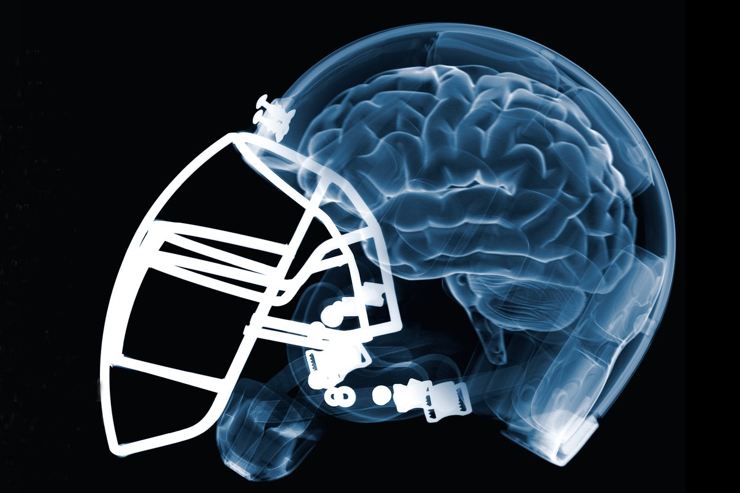  Grant Glennon  Maddie Kahl  ENC 2135  17 April 2018

Works Cited
Chavez, C. (2017, July 25). Boston University Study Finds CTE In 110 Of 111 Brains of Former NFL Players. Retrieved from Sports Illistrated : https://www.si.com/nfl/2017/07/25/boston-university-study-cte-nfl-player-brains
Concussion Legacy Foundation. (n.d.). Retrieved from https://concussionfoundation.org/CTE-resources/what-is-CTE
Ward, J. (2017, July 25). 110 NFL Brains. Retrieved from NYTIMES: https://www.nytimes.com/interactive/2017/07/25/sports/football/nfl-cte.html

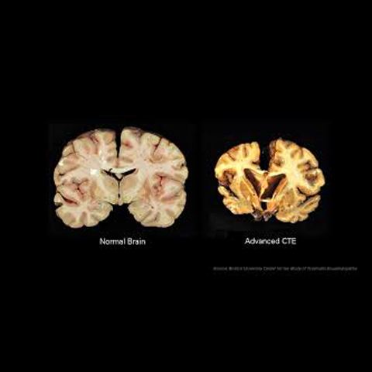  CTE STATISTICS:  In a recent study, it was found that children under the age of 12, are more prone head injuries including, CTE.  Out of 111 players who played in the NFL, it was noted that 110 of them were diagnosed with CTE, which is starkly higher than other levels of football.  As found in the Boston Study, those with CTE, had a higher mortality rate between the ages 41-69 which is comparatively higher than the national average.  (Boston Study 2017, (Ward, 2017)) | “The best available evidence tells us that CTE is caused by repetitive hits to the head sustained over a period of years (Concussion Legacy Foundation, n.d.).”  The more we study this disease the more we can act against it. Our goal is to provide the most updated information to the public so that young athletes and parents know the risks that come with playing Football.  Frequently Asked Questions:  Are CTE like concussions?  CTE and concussions have no relation, one is a degenerate disorder while the other is a more temporary injury.  Does CTE shorten your life?  While no definitive answer has been discovered, there is statistical correlation showing that it may.  How common is it to get CTE?  With findings and recent studies, it is surprisingly more prevalent than it was once thought to be. | Symptoms:  Difficulty thinking  Impulsive behavior  Depression or apathy  Short-term memory loss  Difficulty planning and carrying out  tasks  Emotional instability  Substance abuse  Suicidal thoughts or behavior  The Future:  With new technological advances, new helmets and  tackling techniques, should be able to decrease the  number of CTE cases per year.  With this advent, the sport should be able to continue  without any serious limitations.  Contact Us  Grant Glennon  850-879-0142  gtg17@my.fsu.edu  Website:  https://gtg175.wixsite.com/chronicte

